***Experiment No. 5***

***A.I.M -*** write shell script for finding an element using Binary Search.

***Source Code -:***

echo “Enter the limit:”

read n

echo “Enter the numbers”

for(( i=0 ;i<n; i++ ))

do

read m

a[i]=$m

done

for(( i=1; i<n; i++ ))

do

for(( j=0; j<n-i; j++))

do

if [ ${a[$j]} -gt ${a[$j+1]} ]

then

t=${a[$j]}

a[$j]=${a[$j+1]}

a[$j+1]=$t

fi

done

done

echo “Sorted array is”

for(( i=0; i<n; i++ ))

do

echo “${a[$i]}”

done

echo “Enter the element to be searched :”

read s

l=0

c=0

u=$(($n-1))

while [ $l -le $u ]

do

mid=$(((( $l+$u ))/2 ))

if [ $s -eq ${a[$mid]} ]

then

c=1

break

elif [ $s -lt ${a[$mid]} ]

then

u=$(($mid-1))

else

l=$(($mid+1))

fi

done

if [ $c -eq 1 ]

then

echo “Element found at position $(($mid+1))”

else

echo “Element not found”

fi

***Output - :***

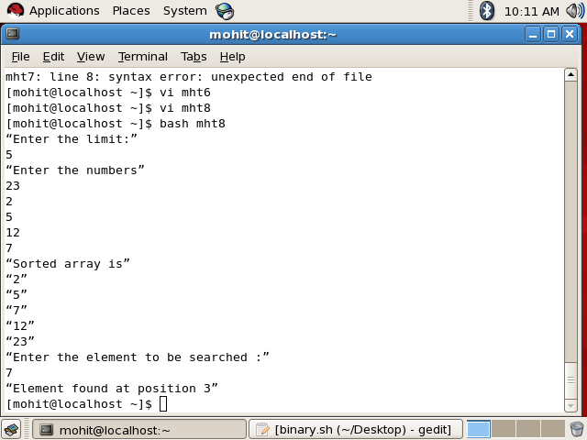

***Experiment No. 6***

***A.I.M-:***  Write a Shell Script to Concatinate two String and also find its length.

***Source Code-:***

echo Enter first string:

read s1

echo Enter second string:

read s2

s3=$s1$s2

len=`echo $s3 | wc -c`

len=`expr $len - 1`

echo Concatinated stringis $s3 of length $len

***Output - :***

